Institute of computer technology

B.Tech-CSE(BDA)

Name:- Anik Shaikh

Sem:-3

Enrollment no.:-23162121020

Batch:-31

Sub:-DBMS

Date:-31/7/24

Practical

Q:- A) Retrieving records from table.

1) Find out the names of all clients.

2) Retrieve the list of names and the cities of all the clients

3) List the various products available from the product_master table.

4) List all the clients who are located in Bombay.

5) Find the names of the salesman who have a salary equal to Rs. 3000

6) List out only unique values for the city of client_master table

7) Display product_master table according to the sell_price of product.

8) Display product_master table according to the sell_price and cost_price.

9) Display product_no, description in descending order of sell_price for product_master table.

A=> Query:- use BDA_23162121021;

set SQL_SAFE_UPDATES = 0;

1)select Name from client_master;

2)select Name, city from client_master;

3)select Description from product_master where Qty_on_hand != 0;

4)select Name from client_master where city = 'Bombay';

5)select S_name from salesman_master where Sal_Amt = 3000;

6)select distinct city from client_master;

7)select sell_price from product_master;

8)select sell_price, cost_price from product_master;

9)select * from product_master order by sell_price desc;

Screenshot:-

1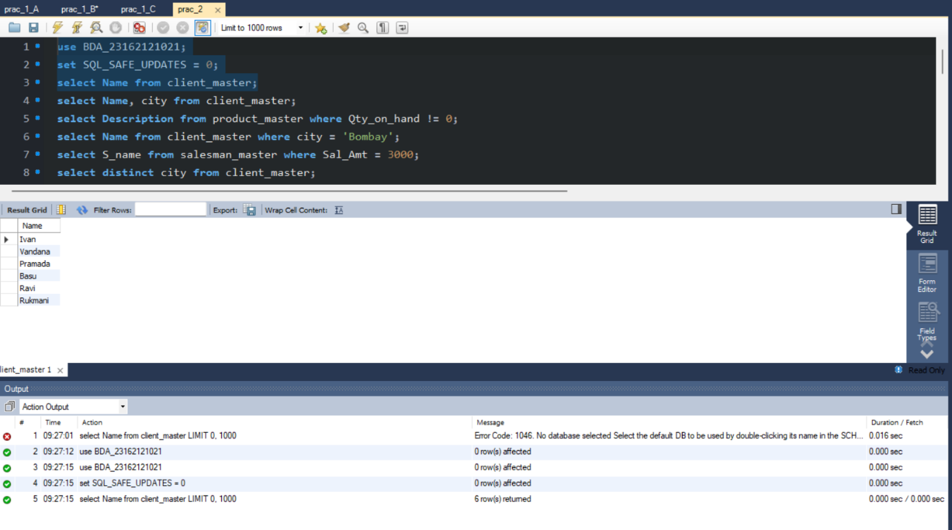2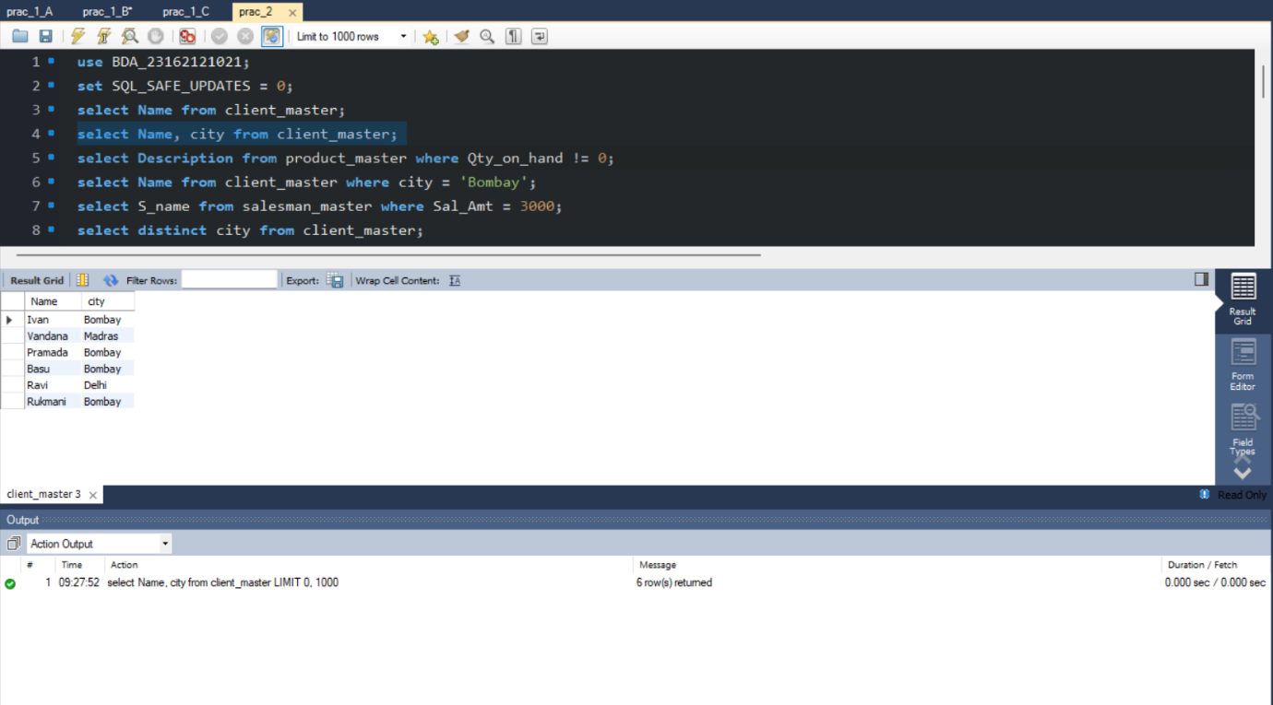3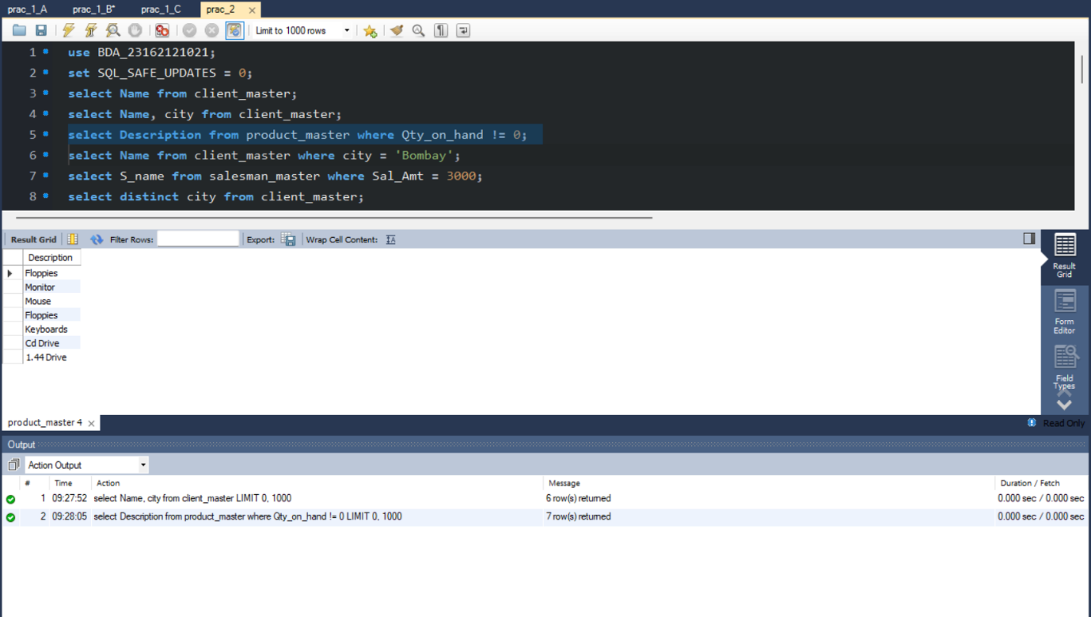4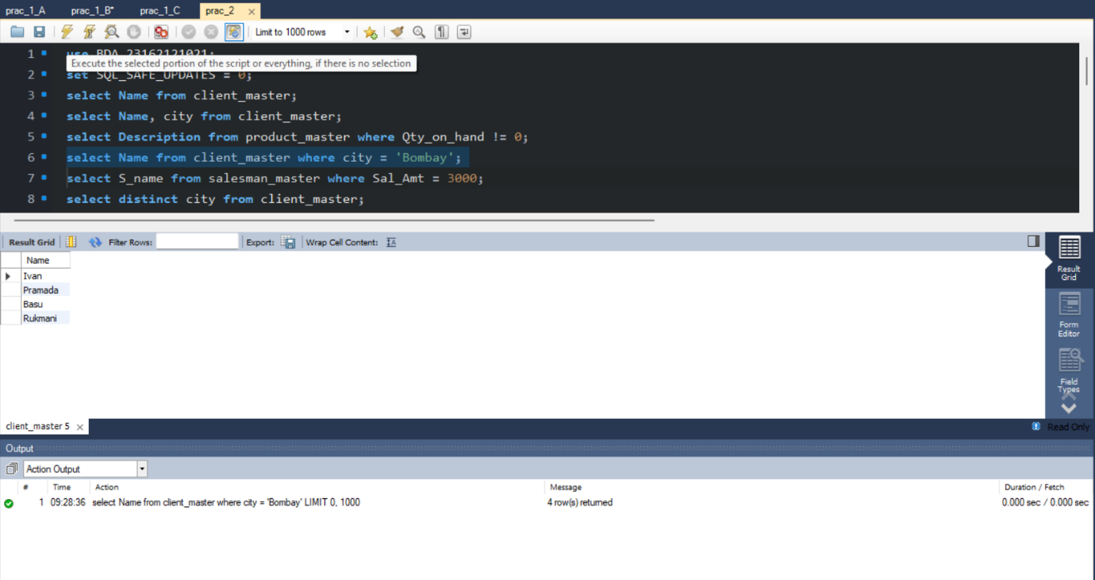

5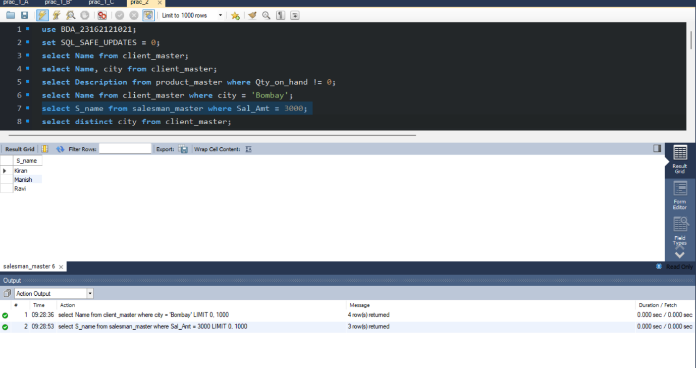6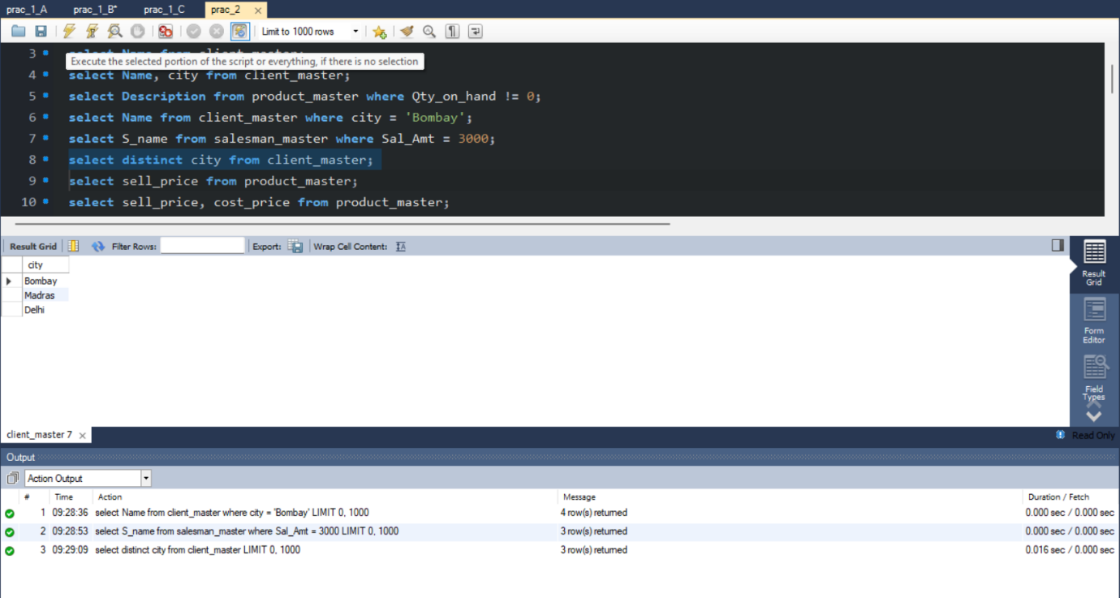7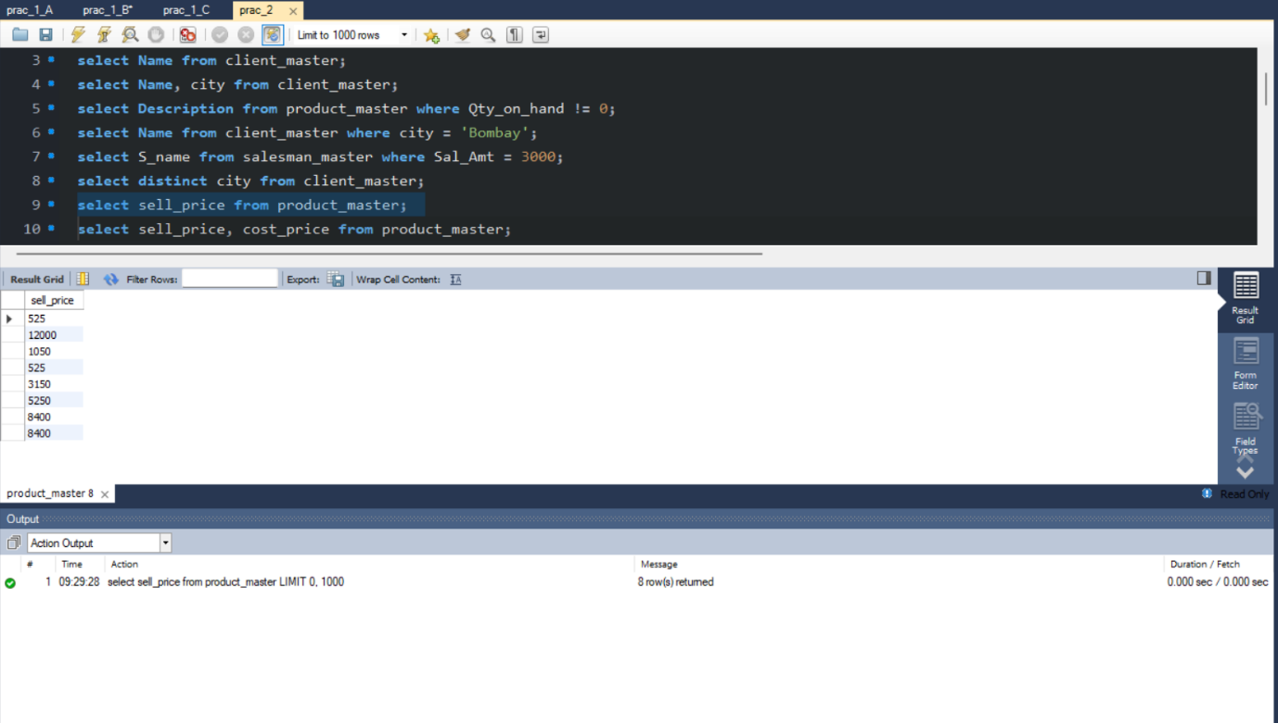8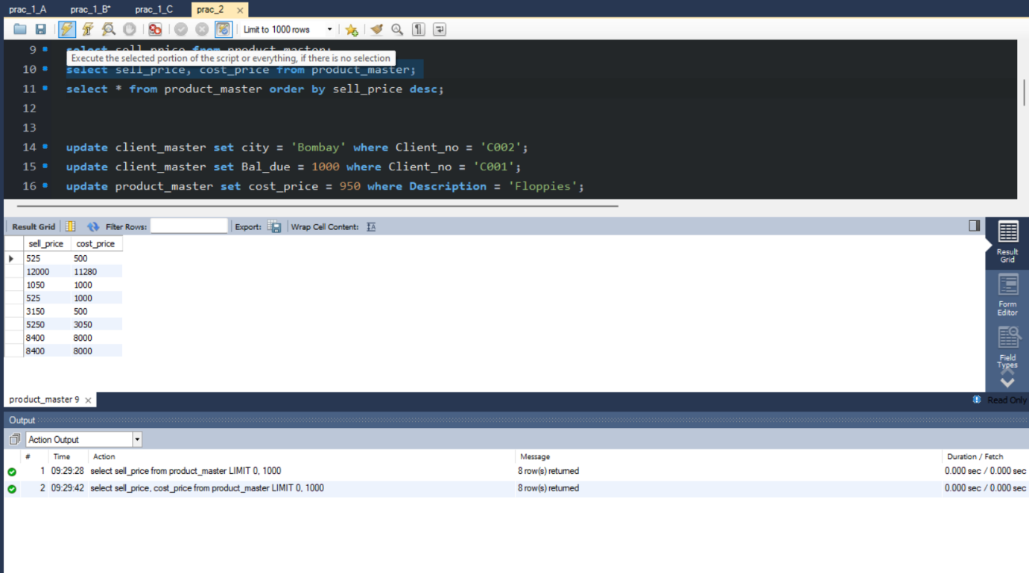9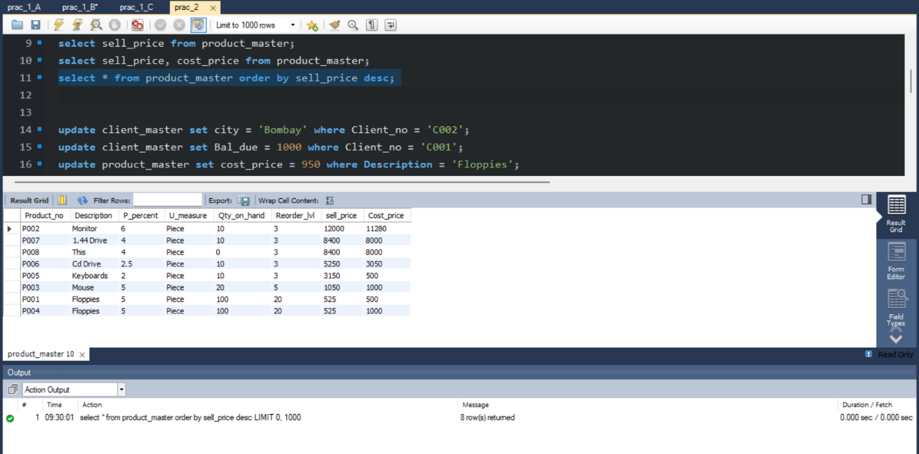

Q:- B) Updating records in a table.

1) Change the city of client_no’C002’ to ‘Bombay’.

2) Change the bal_due of client_no’C001’ to Rs.1000

3) Change the cost price of Floppies to Rs. 950.00

4) Change the city of the salesman to Mumbai.

A=> Query:-

update client_master set city = 'Bombay' where Client_no = 'C002';

update client_master set Bal_due = 1000 where Client_no = 'C001';

update product_master set cost_price = 950 where Description = 'Floppies';

update salesman_master set city = 'Mumbai';

Screenshot:-

1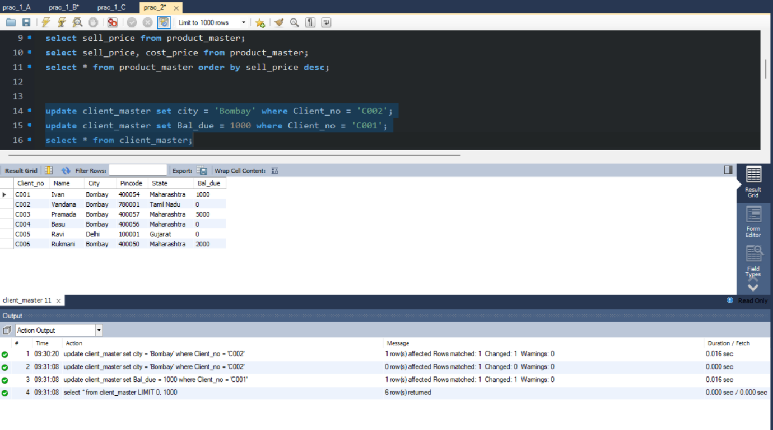

2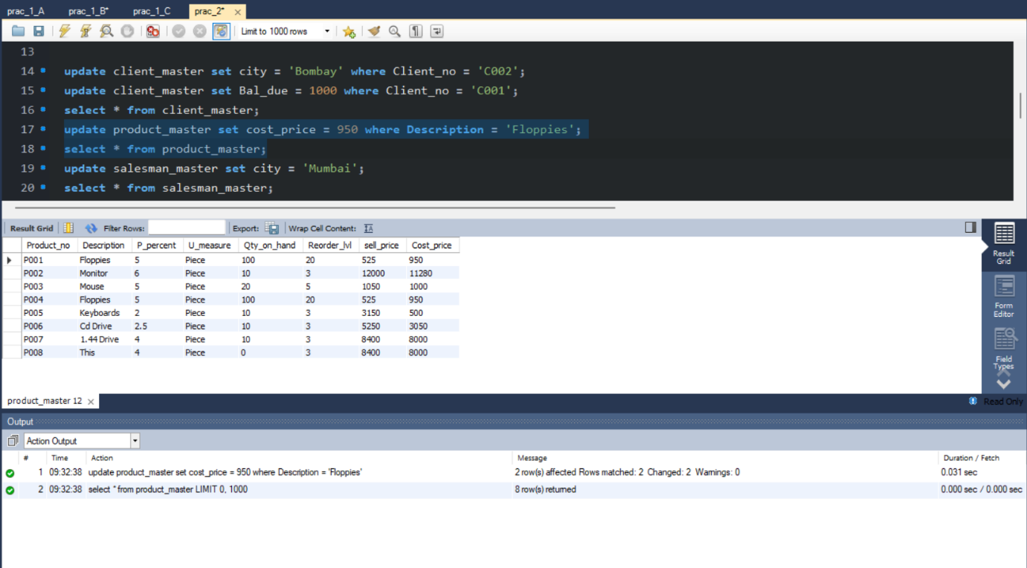

3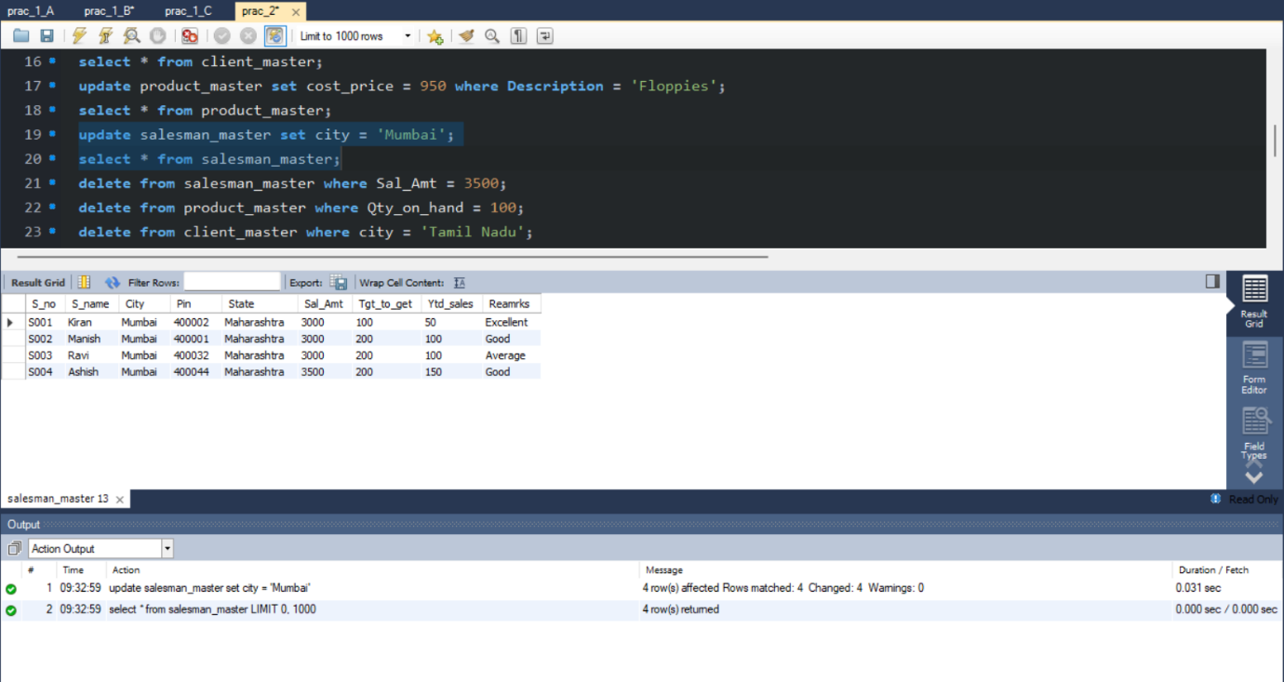

4

Q:- C) Deleting records in a table:

1) Delete all salesman from the salesmane_master whose salaries are equal to Rs. 3500.

2) Delete all products from product_master where the quantity on hand is equal to 100.

3) Delete from client_master where the column state holds the value ‘Tamil Nadu’.

A=> Query:-

delete from salesman_master where Sal_Amt = 3500;

delete from product_master where Qty_on_hand = 100;

delete from client_master where city = 'Tamil Nadu';

Screenshot:-

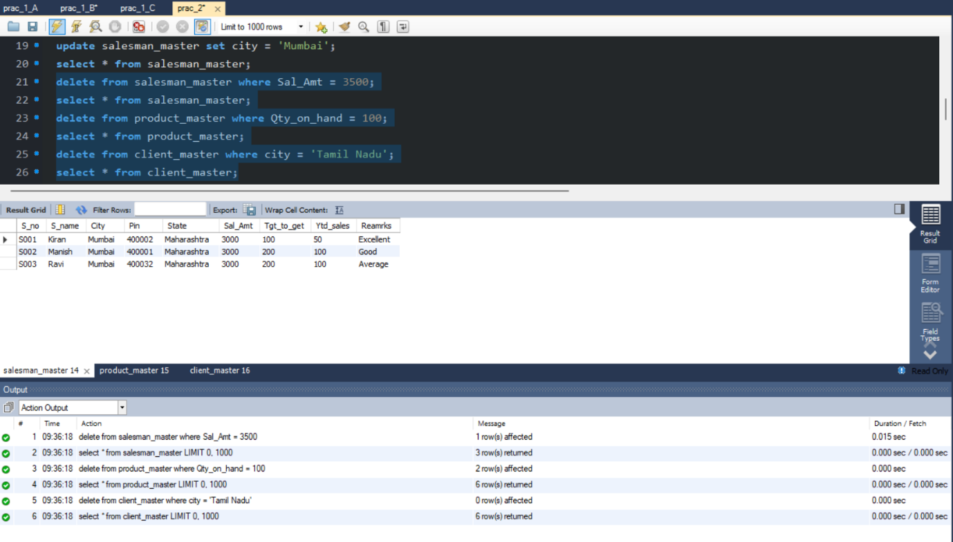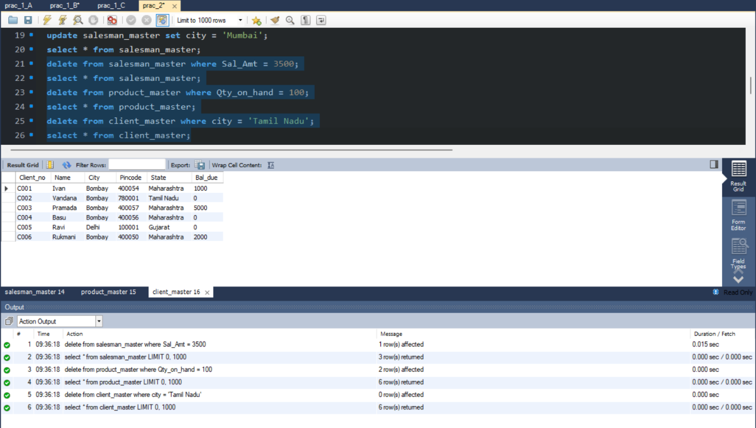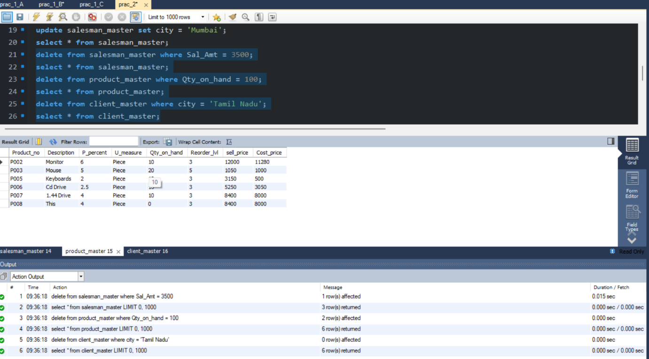

Q:- E) Altering the table structure:

1) Add a column called ‘telephone’ of datatype ‘number’ and size=10 to the client_master table.

2) Change the size of sell_price column in product_master to 10,2.

3) Rename column telephone to new name as contact for client_master table.

4) Delete column contact from client_master table.

A=> Query:-

alter table client_master add telephone int(10);

alter table product_master modify sell_price Numeric(10,2);

alter table client_master rename column telephone to contact;

alter table client_master drop contact;

Screenshot:-

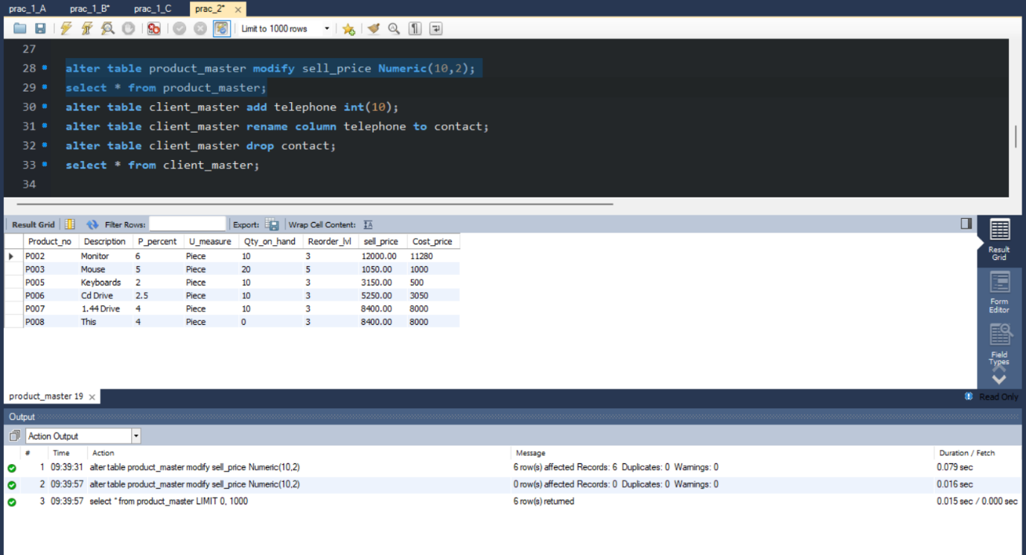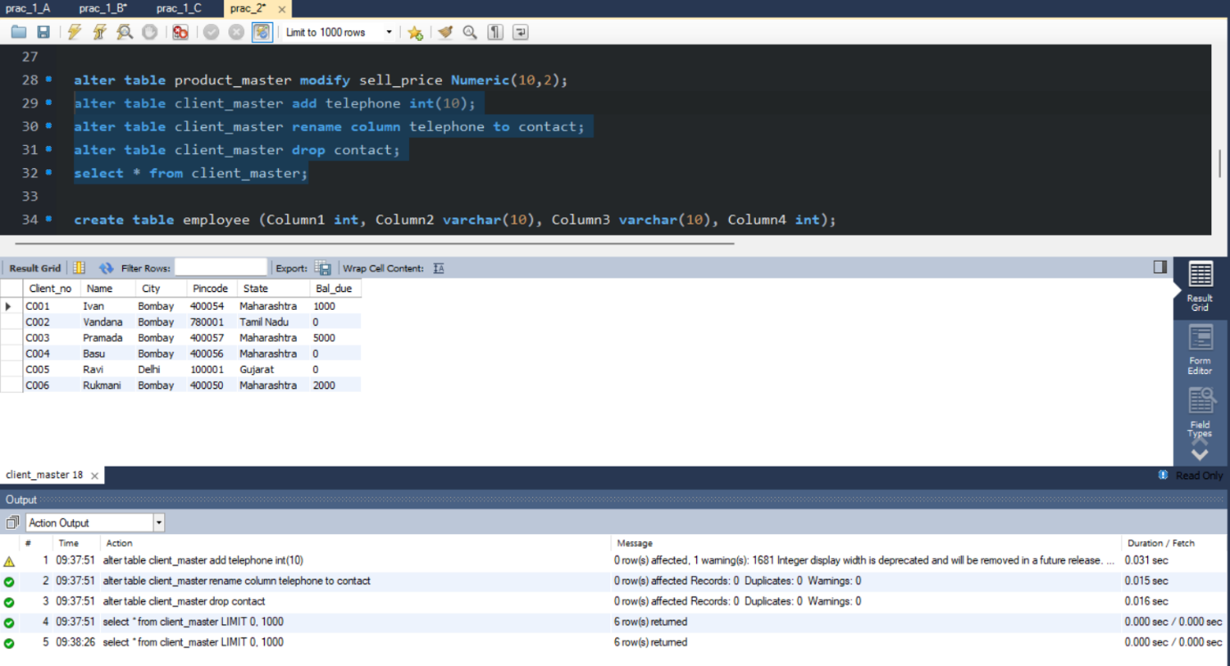

Q:- F) Deleting the table structure along with data:

Create table employee with 4 columns and 5 rows.

1) Destroy the table employee along with its data.

A=> Query:-

create table employee (Column1 int, Column2 varchar(10), Column3 varchar(10), Column4 int);

insert into employee values(1, 'anik', 'okay', 10);

insert into employee values(2, 'this', 'nah', 8);

insert into employee values(3, 'that', 'mate', 7);

insert into employee values(4, 'nope', 'yo', 6);

insert into employee values(5, 'yess', 'buddy', 4);

drop table employee;

Screenshot:-

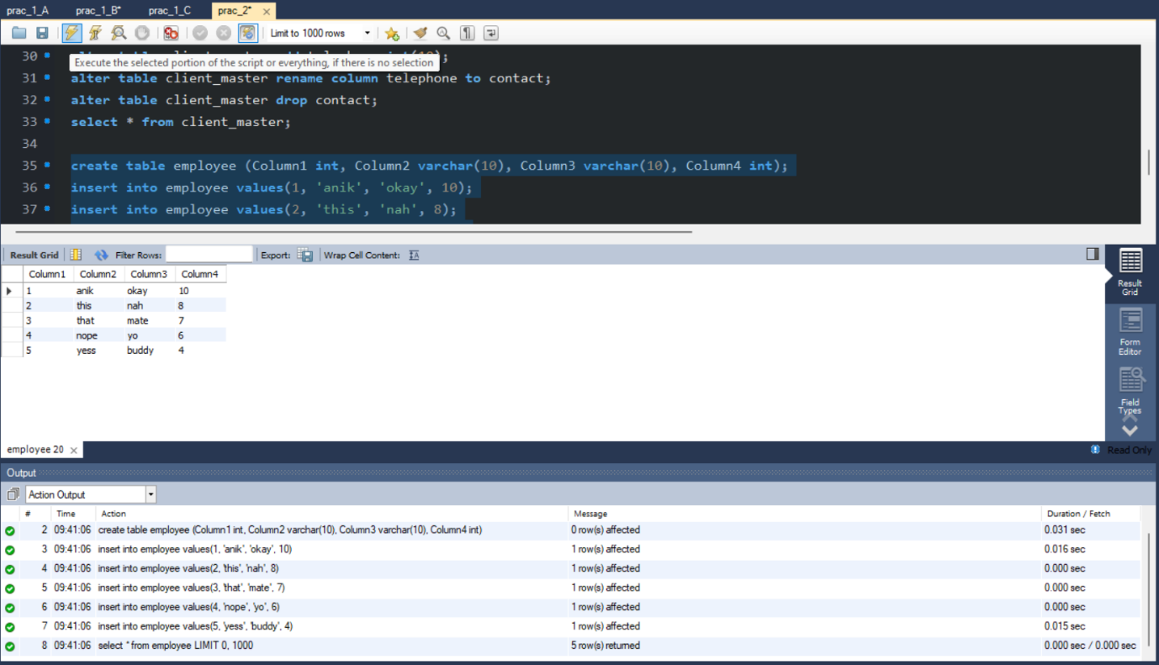

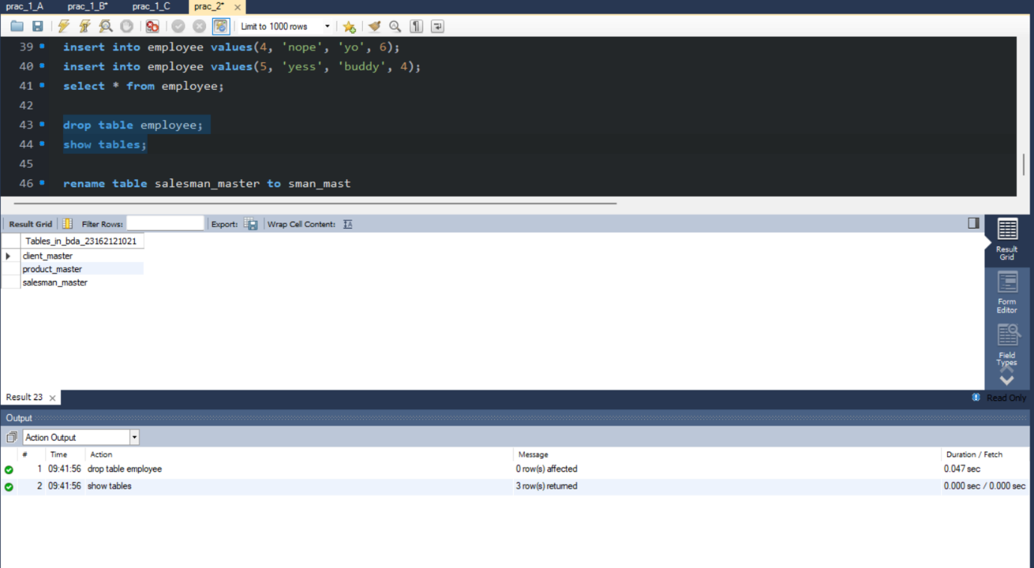

Q:- G) Renaming the table:

1) Change the name of the salesman_master table to sman_mast.

A=> Query:-

rename table salesman_master to sman_mast

Screenshot:-

